**A Narendiran**

**PES1UG19CS001**

**A Sec**

**Assignment 4 - Introduction to Apache Zookeeper**

Task A: Installing Zookeeper

1a

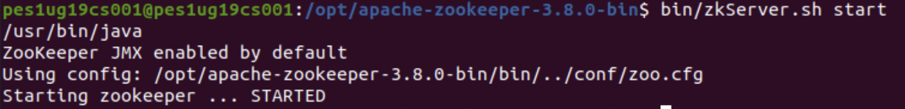

Task B: Getting Familiar with Zookeeper

2a

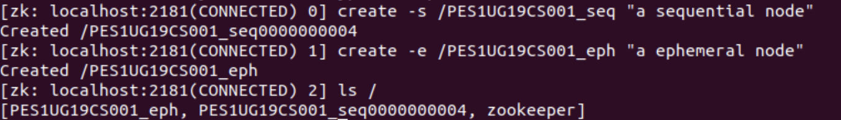

2b



2c

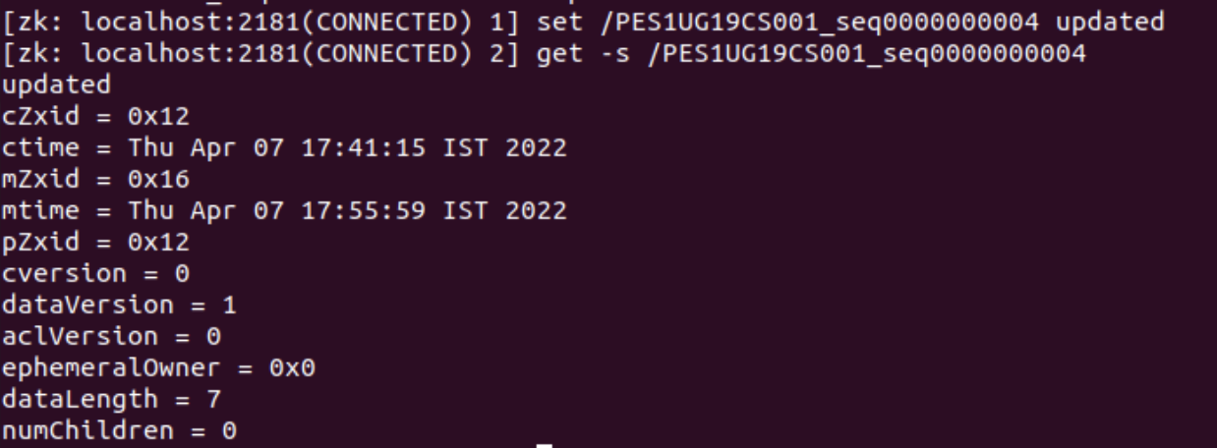

2d

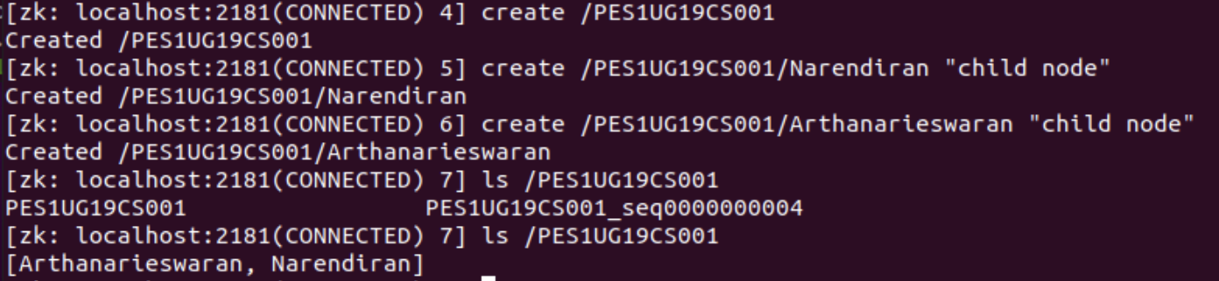

Task 3: Naive Leader Election with Zookeeper CLI - Understanding the Algorithm

3a

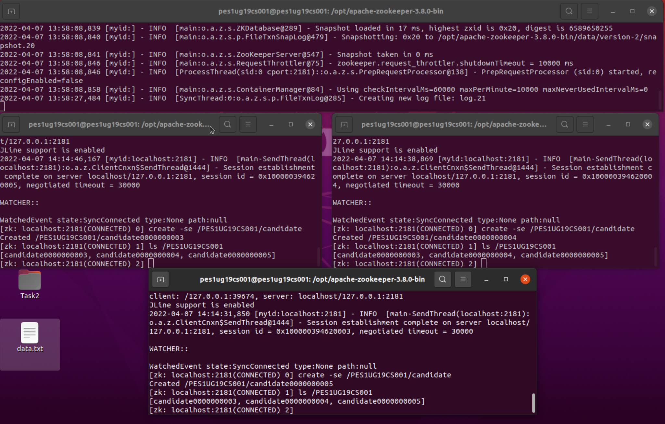

3b

